**Assignment 3.4**

Note : Since no data is provided, using following dataset

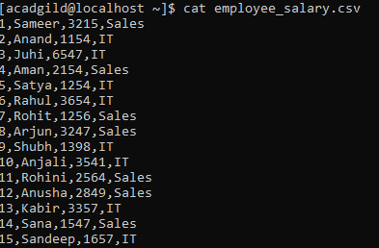

CREATE EXTERNAL TABLE IF NOT EXISTS employee_salary (id int, name String, salary int, unit String) ROW FORMAT DELIMITED FIELDS TERMINATED BY ',';

LOAD DATA LOCAL INPATH '/home/acadgild/employee_salary.csv' INTO TABLE employee_salary;

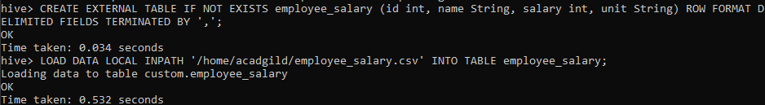

1. **Get a list of employees who receive a salary less than 100, compared to their immediate employee with higher salary in the same unit**

WITH temp as ( SELECT id, name, salary, unit , LEAD(salary,1) OVER (PARTITION BY unit ORDER BY salary) - salary AS salary_diff FROM employee_salary) SELECT * FROM temp WHERE salary_diff < 100;





1. **List of all employees who draw higher salary than the average salary of that department**

select * from employee_salary a WHERE salary > (SELECT avg(salary) FROM employee_salary b where b.unit = a.unit GROUP BY unit);



